**CSA1518-CLOUD COMPUTING** T. Ashwath

192011375

**Expt:10**

Create a Cloning of a VM and Test it by loading the Previous Version/Cloned VM

**IMPLEMENTATION:**

STEP 1:

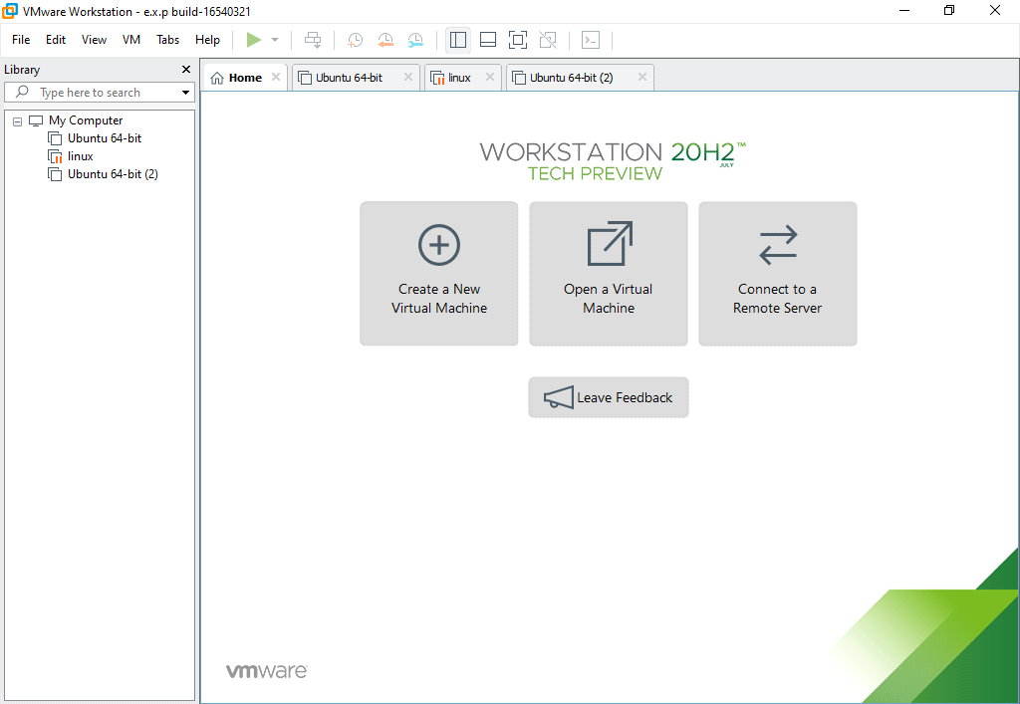

STEP 2: GO TO VM AND GOTO MANAGE AND CLICK CLONE

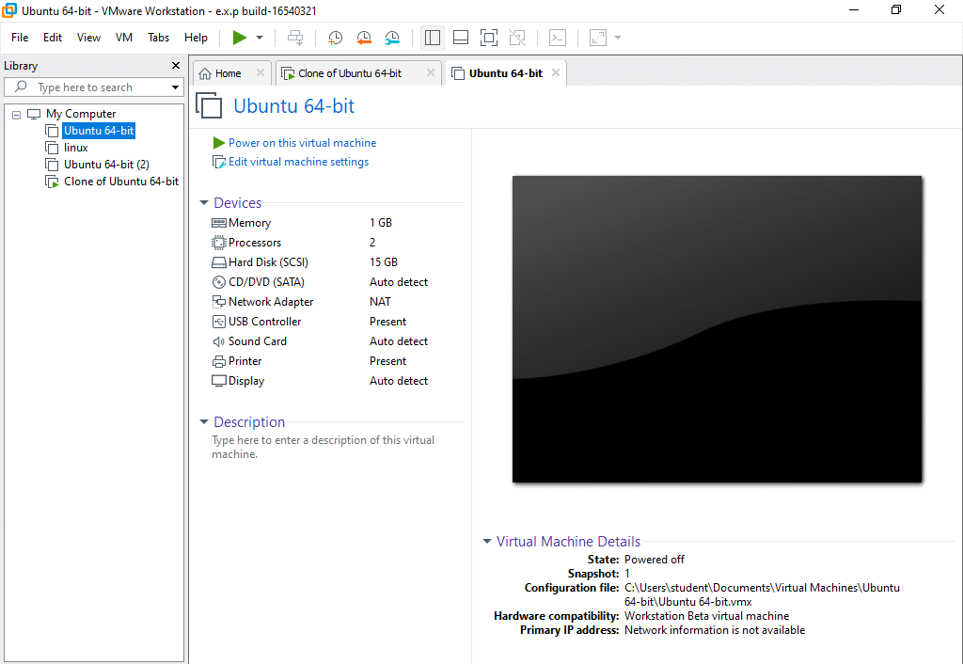

STEP 2:CLICK ON MANAGE AND CLONE

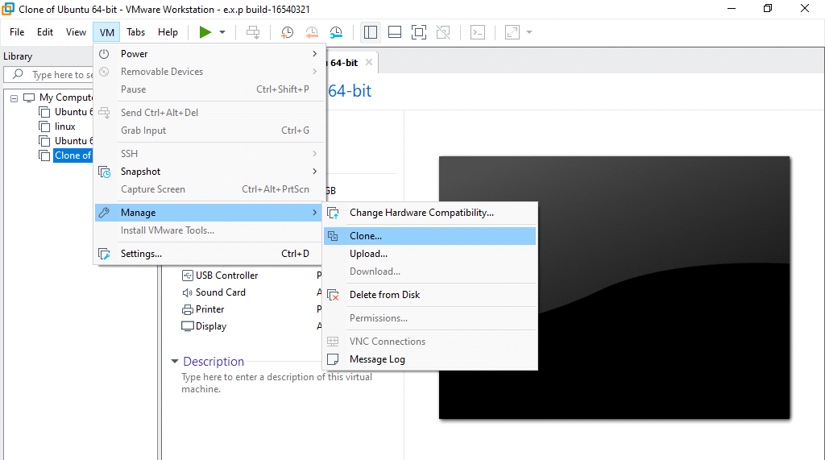

STEP 3:SELECT CLONE SOURCE

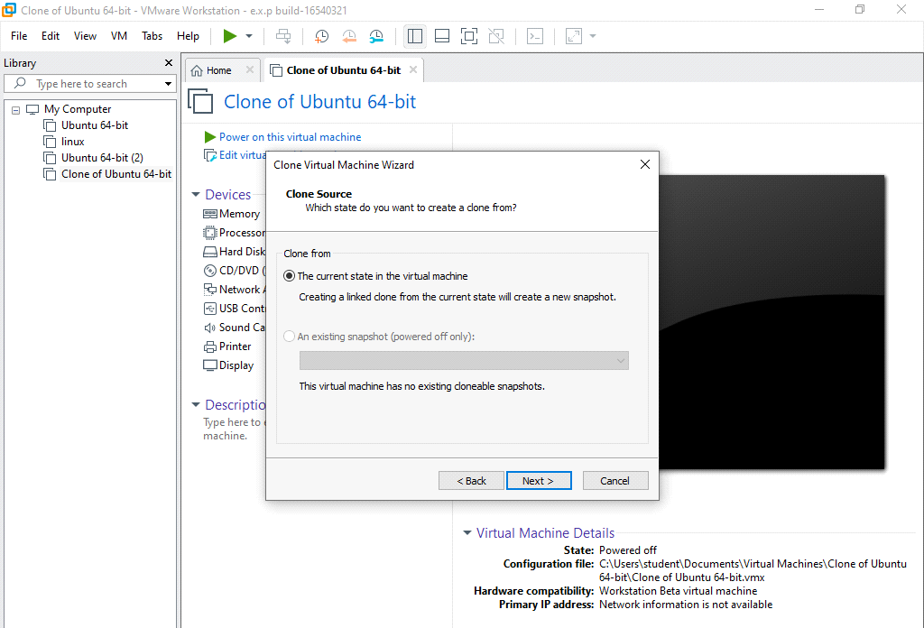

STEP 4:SELECT CLONE TYPE

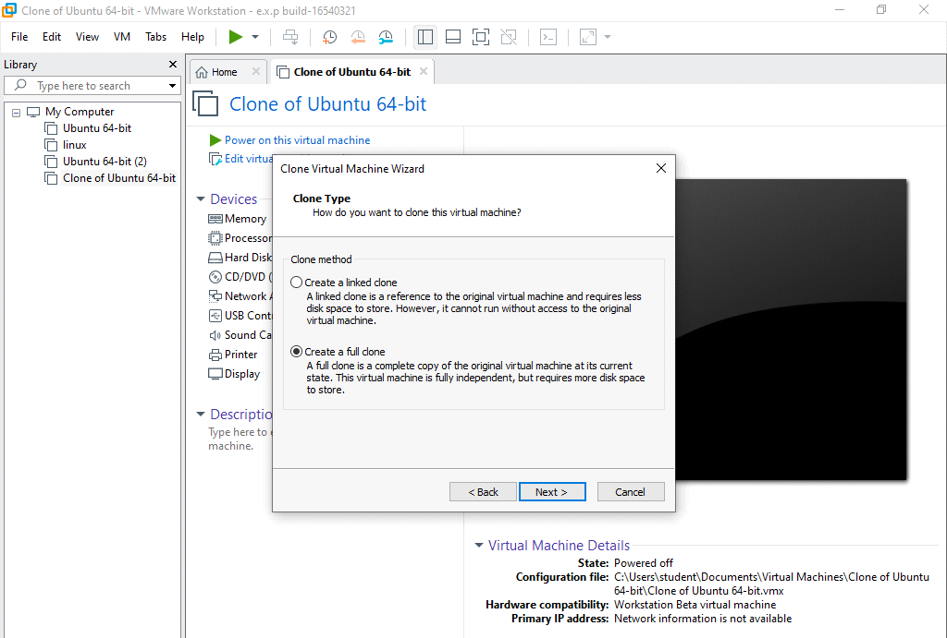

STEP 5: GIVE VIRTUAL MACHINE NAME

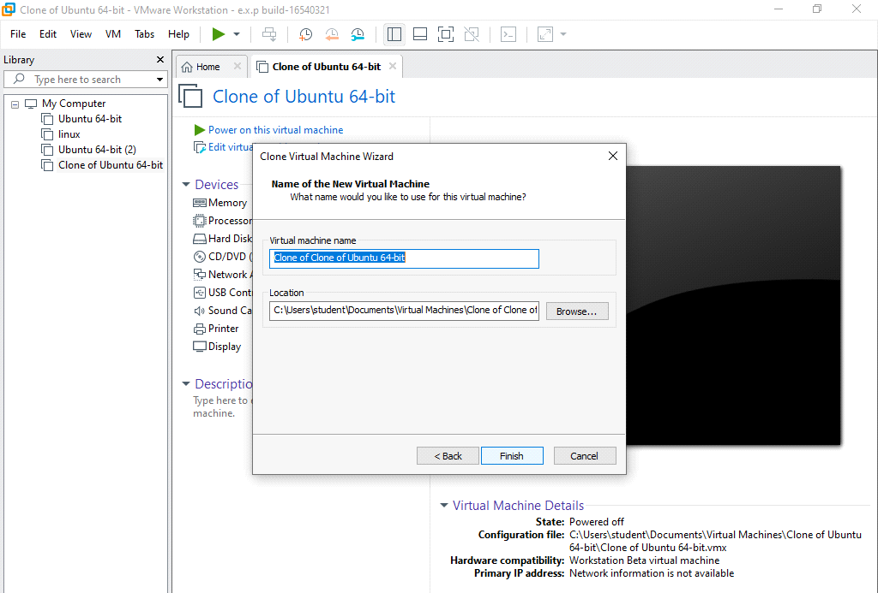

STEP 6:POWER ON VIRTUAL MACHINE

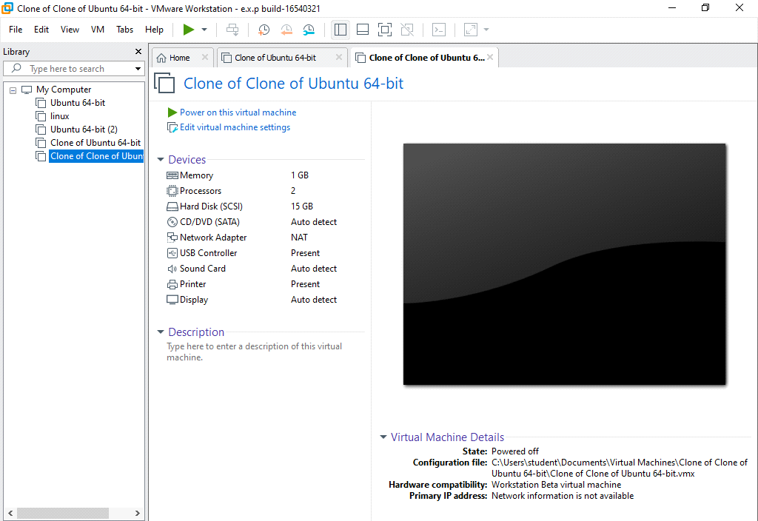

STEP 7:OUTPUT

